The Graph of y = (-1)^{x}
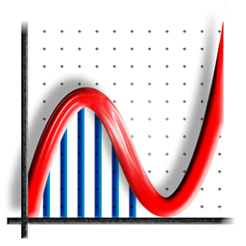

by Philip Lloyd
If we just choose INTEGER values of x we just get the y values +1 and -1
eg (0, 1), (1, –1), (2, 1), (3, –1) ... and (–1, –1), (–2, 1), (–3, –1)...
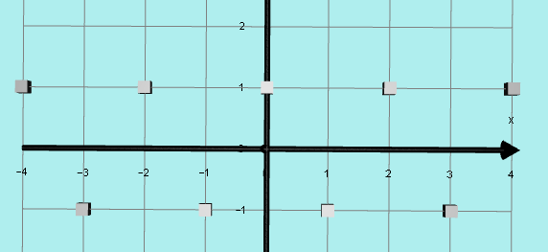

However, if we choose x = 0.1 we get y = 0.95 + 0.31i
x = 0.6 we get y = –0.31 + 0.95i
x = 1.2 we get y = –0.81 – 0.59i
These points have a REAL PART and an IMAGINARY PART. In order to make sense of this, we need to be able to plot these complex y values so we need another axis besides the normal x and y axes.
I will use only REAL x VALUES on the x axis and in order to plot points such as y = 0.95 + 0.31i I will put the REAL PART (0.95) on the normal y axis
and the IMAGINARY PART (0.31i) on the z axis (imaginary y axis), using Autograph.
The DOMAIN of this graph is all the real numbers (ie on the real x axis).
But instead of a simple y AXIS we now have a complex y PLANE.
I plotted several POINTS in this way eg (0.5, 0 + i) and ( 0.8, – .81 + .59i)
and produced the following graph:

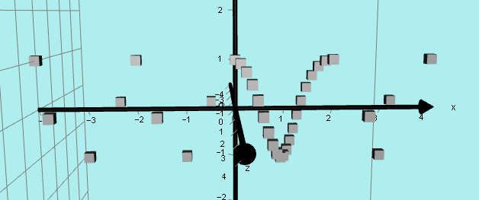

By joining these points we produce this beautiful helix.

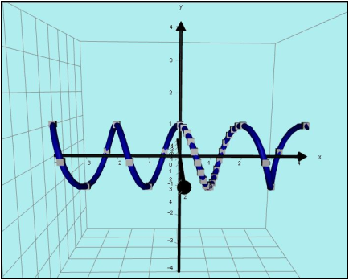

End view:
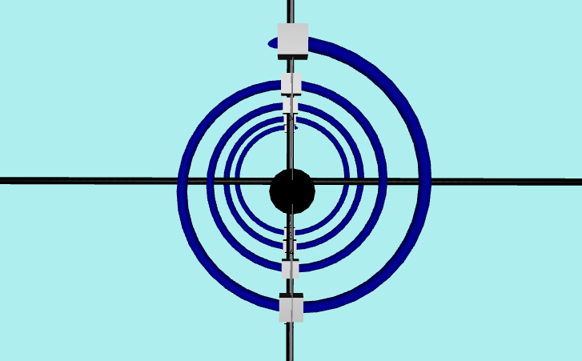

Auckland, February 2016

